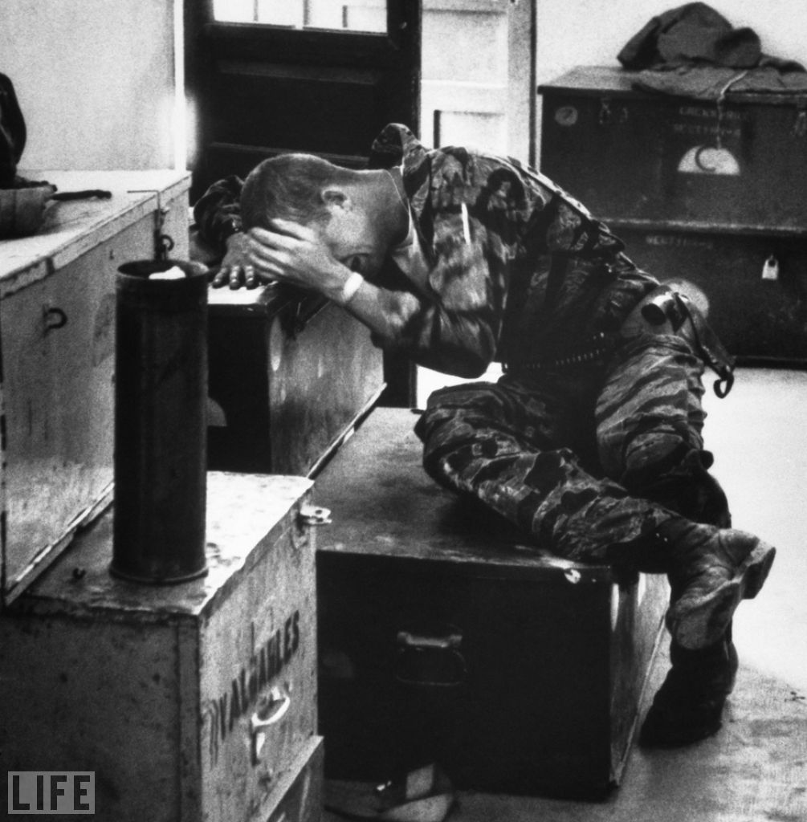

This image from Life magazine pulls at your emotions so much it almost becomes difficult to look at. This soldier has been through such hardships that he finally broke down. The image of a soldier - who has been trained to be as strong and stable as humanly possible, almost robotic in the field - crumpled over these containers really hits the heart hard. The use of a black and white photo really pulls in the viewer as the colors don't distract from its meaning. In addition, the bright background and the dark foreground really focus the eye on the subject of this photograph.